**Website 1st Phase Content Final Touch**

1. 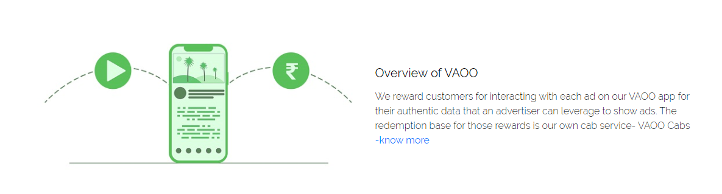
2. OVERVIEW | ~~Overview of VAOO~~
3. Fullstop in the end of VAOO Cabs.
4. 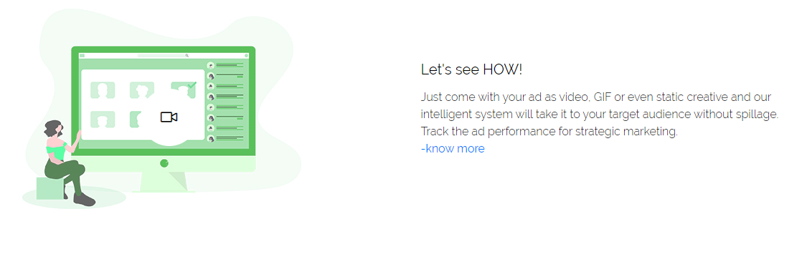
5. Make your ads VAOO! | ~~Let’s see HOW!~~
6. 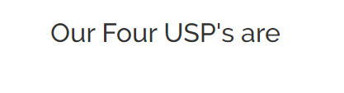  
   a. VAOO FACTORS | ~~Our Four USP’s are~~
7. 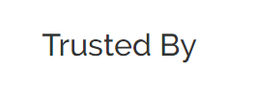  
   a. VAOO PARTNERS | ~~Trusted By~~
8.   
     
   a. LOGO bigger in size  
   b. © 2020 VAOO Adtech Pvt. Ltd. | ~~Copyright © 2020: VAOO Adtech Pvt Ltd~~
9. 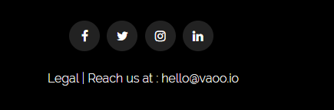  
     
   a. *Legal* has to be a button which leads to a page full of legal documents *(Will share the documents)* and should read **LEGALS**b. ‘Reach us at : hello@vaoo.io’ is removable from beside LEGALS given it won’t be a link
10. a. Enable every person and corporate to make the most of their time - *in one line*
11. 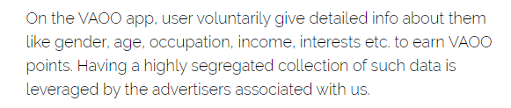  
    a. …app, ~~user~~ voluntarily… | users  
    b. …about ~~them~~ like… | themselves
12. 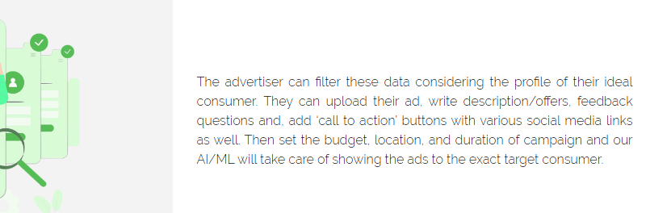
13. The ~~advertiser~~ can… | advertisers
14. Ideal ~~consumer~~… | consumers
15. …target ~~consumer.~~ | consumers
16. 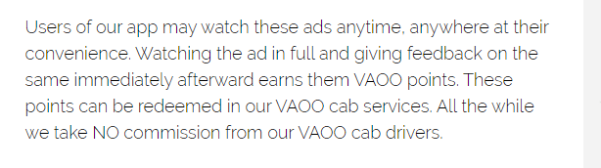  
    a. ~~All the while…cab drivers.~~  | Benefiting from the demand and supply of digital ads on our app, we take NO commission from our VAOO cab drivers.
17. 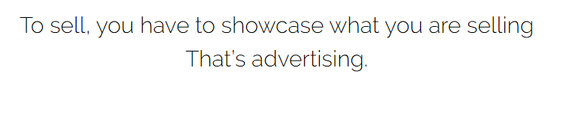a. VAOO AD FORMATS
18. 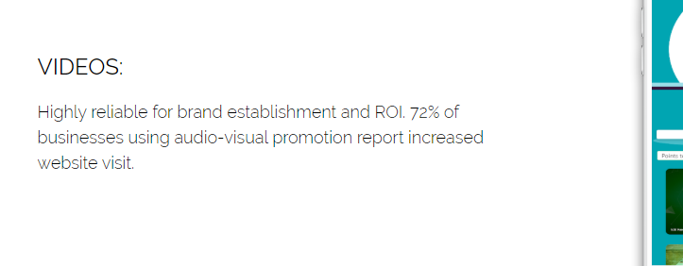  
    a.b.c. NO **COLON** and **PLURAL** for VIDEO, GIF and HOT DEAL
19. 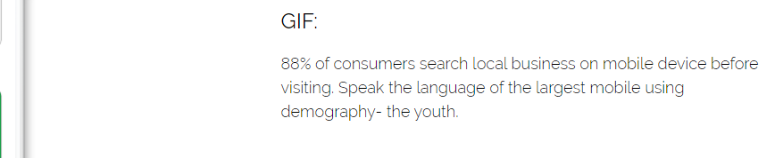  
    a. …before visiting. | … before visiting the shop.
20.   
    a. ~~VAOO TOUR~~  | VAOO RIDE
21. 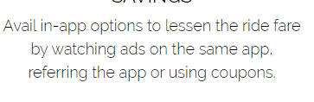  
    a. Avail in-app options to lessen the ride fare by watching ads, referring the app or using coupons.
22. 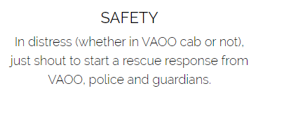  
    a. In distress (whether in VAOO cab or not), just shout to generate a rescue request from the app to VAOO control panel.
23. 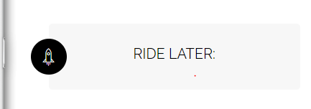  
    a. NO **COLON** after RIDE LATER
24. 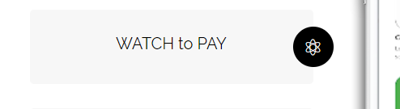  
    a. WATCH and EARN
25. 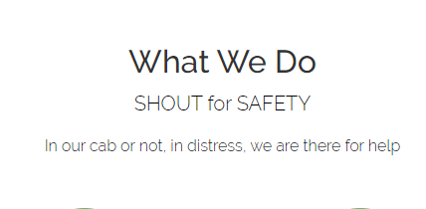  
    a. Remove ~~WHAT WE DO~~b. Make **SHOUT for SAFETY** the title  
    c. NO Subheadline
26. 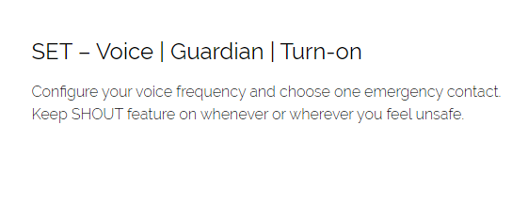  
    a.  **~~SET –~~**
27. 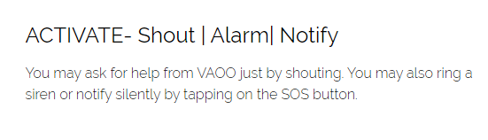  
    a. **~~ACTIVATE-~~**
28. 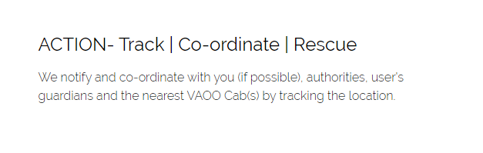  
    a. **~~ACTION-~~**b. We notify and co-ordinate with you (if possible), the authorities, your guardians and the nearest VAOO Cab(s) by tracking your location.
29. 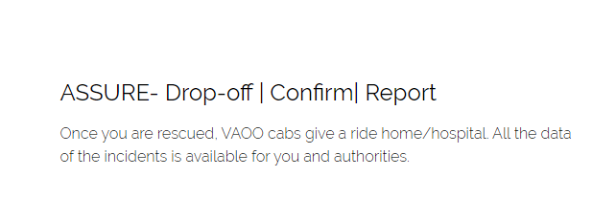  
    a. **~~ASSURE-~~**   
    b. Once you are rescued, we give you a cab ride home/hospital. All the data of the incident is available for you and the authorities with discretion.
30. 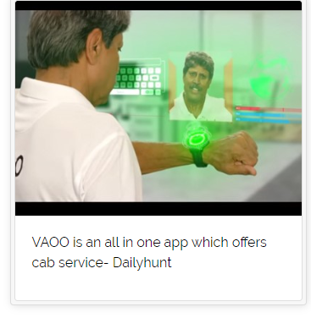  
    a. VAOO is an all in one app which offers cab service – Dailyhunt
31.   
    a. Remove it entirely to We’d love to hear from you (no underline though)
32. 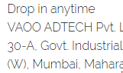  
    a. Remove ‘Drop in anytime’
33. 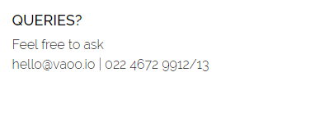  
    a. No question mark after QUERIES  
    b. Remove ‘Feel free to ask’
34. 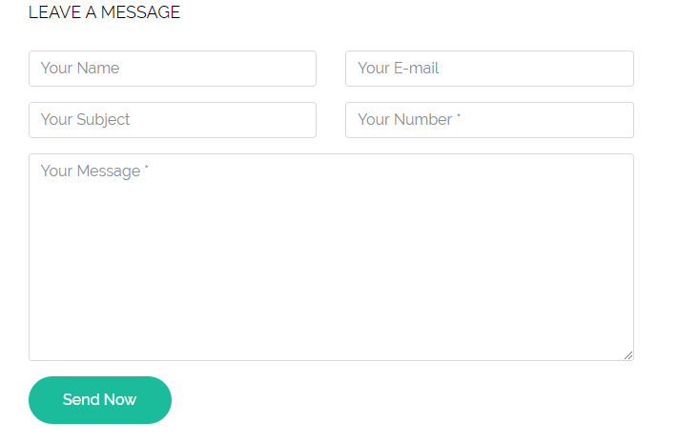a. Remove Your from every box  
    b. ~~Your Message*~~ | How may we help you?